README

================

1. **How to compile**

Download and open the file in a Python environment. For my file, they are running on Google Colab so some commands like drive.mount(...) are added

1. **How to execute**

The structure of each file is the same.

1. Initialization of the model and dataset
2. Get the artifact (implementation part)
3. Get the artifact (Research part - Stacked approach)
4. Classifier MLP
5. Classifier XBG

Remark: Parts B and C && Parts D and E are independent. That means you can run part C directly without running part B

If you want to execute the part, you can directly execute all the blocks within that part sequentially. Also, before execution, you need to change the path of the drive to your own drive or storage location.

If you want to execute parts D and E, you need to execute parts B or C first in order to get the artifact data and store it on the drive.

1. **The description of each source file**

MSBD5002_activation.ipynb:

This is the file for the experiment on fully-connected activation score

MSBD5002_attention.ipynb:

This is the file for the experiment on self-attention score

1. **An example to show how to run the program**
2. Run parts A and B by executing all the blocks sequentially
3. For part B, store the artifact data in the drive by the line

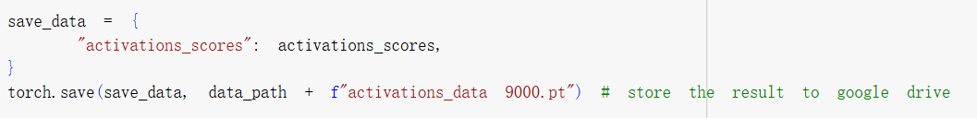

1. Run part E to get the XGB classifier.

Load the data from the drive by change the name of the file

1. **The operating system you tested your program (e.g., linux and Windows)**

The code is tested on Windows, especially i am using the Google colab environment in the execution of the code